1.What is mean by RICEFW?
Reports, Interface, Conversion, Enhancement, Forms, Workflow / Web Dynpro.
Reports
A report is a document that presents information displayed in an organized format. Display in a predefined format.
Types of Reports Classical Reports, Interactive Reports, ALV (ABAP List Viewer)Reports.
Interface
Interfaces are used to connecting from SAP to SAP as well as SAP to non-SAP. Interfaces are ALE/IDOCS, BAPI.
BAPI – Business Application Programming Interface
I Doc (intermediate document) is a standard data structure used in SAP applications to transfer data to and from SAP system applications and external systems. Using I Docs, companies with SAP ERP systems, for example, can exchange data with external entities like their partners or customers.
In an SAP System the Application Link Enabling (ALE) is one of the core integration technologies. It involves the exchange of hierarchical data documents known as Intermediate Documents (I Docs).
Conversion
Conversion programs are used to transverse the data from file to SAP system. Conversion programs are BDC, LSMW.

Enhancement
Enhancements are used to adding some additional functionality to the standard functionality without disturbing the standard functionality. Enhancements are BADI, user exists, customer exits, enhancement frame work, enhancement spot.
Forms
Forms are used to design the business documents such as offer letters, experience letters, pay bills etc. Forms are SAP Script, SMART forms.
Work flow
Work flow is used to automate the exist business process & used to identify the work load of employee as well as performance of the employee.
2. What are the Types of projects?
Implementation project, Up gradation project, Maintenance / Support project,
Roll out project.
Implementation project
Whenever we want to develop the SAP from fundamental onwards then we go for implementation project. Implementation project takes 1 year to 3 years.
Phases of implementation project: Project preparation phase, Business Blue Print phase, Realization phase, Post preparation phase, Go-live & support phase.
As the word suggests, i mean, IMPLEMENTATION means implementing Business Processes. After purchasing the SAP (ERP), Companies do Study the Methodologies and various process and case studies. In Implementation, Several People works on various functional modules listed below (can be considered as SAP BI ARCHITECTS, DESIGNERS, SAP CONSULTANTS). Every Module has its Importance and is linked to other module in one or many ways (SAP is all Tables and Table Relations).
Function Modules Financial Accounting (FI), Financial Supply Chain Management (FSCM), Controlling (CO), Materials Management (MM), Sales and Distribution (SD), Logistics Execution (LE), Production Planning (PP), Quality Management (QM), Plant Maintenance (PM), Project System (PS), Human Resources (HR).
Technical Module SAP Technical (ABAP Programmers), Basis & Security Consultants: OTHERS, BIW (BI or BW) - Business Information Warehouse, CRM - Customer Relationship Management, IDES - International Demonstration and Education System, KW - Knowledge Warehouse, MDM - Master Data Management.
Up gradation project
Whenever the version is changed if you want to implement the new technologies into existing system then you go for up gradation project. Up gradation project takes 30 days to 3 months. Maintenance / Support project After go level support phase each and every
Support project
Company requires 24*7 supports. Then they go for support project.
Roll out project
Whenever we purchase a new company if you want to extend the same SAP to new company, then we go for roll out project. If you want to implement the new module in the existing SAP system then we go for roll out project.
3. What are the types of Operators ?
In ABAP we’ve 5 types of operators.
Mathematical Operator or Arithmetic Operators +, -, *, **Exponential (3 * * 3 = 27), / Division (4 / 2 = 2) Quotient, MOD Reminder of division 5 mod 2 = 1 Of two numbers.
Comparative Operator <, <=,>, >=, =, <>.
Relational or Logical Operator AND, OR, NOT PARAMETERS.
Conditional Operators IF-END IF, CASE-ENCASE.
Looping Operators DO-END DO, WHILE-END WHILE.
4.What is the difference between EXIT and STOP?
STOP
This terminates the block and executes end-of selection. This statement terminates a processing block in an executable program. The statement is only intended for use in the INITIALIZATION, AT SELECTION-SCREEN, START-OF-SELECTION, and GET events. It terminates the current processing block in an executable program and triggers the END-OF-SELECTION event.
EXIT
It terminates the loop processing and process the next statements. EXIT statement is used to terminate an entire loop unconditionally and immediately. As soon as the EXIT statement is executed, the loop is terminated and the statements following the loop are processed. Terminates loop processing (DO, WHILE, LOOP, SELECT).
5.What is Check?
It evaluates the subsequent logical expression if it.
6. What is Continue?
Terminates the current loop pass, returns the Processing to the beginning of the loop and starts the next loop pass.

REPORT Z09_03_OPERATORS_PR9.
DATA: VAR1 TYPE I VALUE 0.
WHILE VAR1 < 5.
VAR1 = VAR1 + 1.
IF VAR1 = 2.
CONTINUE.
ENDIF.
WRITE / VAR1.
ENDWHILE.

REPORT ZYP_TEST_PROGRAM.
DATA: IT_MARA TYPE TABLE OF MARA,
WA_MARA TYPE MARA.
PARAMETERS: P_MATNR TYPE MARA-MATNR.
SELECT SINGLE * FROM MARA INTO WA_MARA WHERE MATNR = P_MATNR.
IF WA_MARA IS INITIAL.
EXIT. "exit program
ENDIF.
WRITE: / WA_MARA-MATNR, WA_MARA-MTART, WA_MARA-MATKL.
STOP.

REPORT ZYP_TEST_PROGRAM.
DATA: IT_MARA TYPE TABLE OF MARA,
WA_MARA TYPE MARA.
START-OF-SELECTION.
SELECT * FROM MARA INTO TABLE IT_MARA UP TO 50 ROWS.
STOP.
END-OF-SELECTION.
LOOP AT IT_MARA INTO WA_MARA.
WRITE:/ WA_MARA-MATNR, WA_MARA-MTART, WA_MARA-MATKL.
ENDLOOP.

CONTINUE:
REPORT ZYP_TEST_PROGRAM.
DATA: IT_MARA TYPE TABLE OF MARA,
WA_MARA TYPE MARA.
START-OF-SELECTION.
SELECT * FROM MARA INTO TABLE IT_MARA UP TO 50 ROWS.
LOOP AT IT_MARA INTO WA_MARA.
IF WA_MARA-MTART = 'HALB'."Skip if material type is 'HALB'
CONTINUE. "Skip the record and go for next record
ENDIF.
WRITE:/ WA_MARA-MATNR, WA_MARA-MTART, WA_MARA-MATKL.
ENDLOOP.
Return:
It terminates the current loop pass when condition is matched.
REPORT ZYP_TEST_PROGRAM.
DATA: IT_MARA TYPE TABLE OF MARA,
WA_MARA TYPE MARA.
START-OF-SELECTION.
SELECT * FROM MARA INTO TABLE IT_MARA UP TO 50 ROWS.
END-OF-SELECTION.
LOOP AT IT_MARA INTO WA_MARA.
IF WA_MARA-MTART = 'HALB'.
RETURN.
ENDIF.
WRITE:/ WA_MARA-MATNR, WA_MARA-MTART, WA_MARA-MATKL.
ENDLOOP.
7.Transaction code creation? SE93
8.What is the database table name for Transaction code?
TSTC – it contains all transaction code information
9.What are the options will be in transaction code creation?
Dialog transaction, Report transaction, OO Transaction, Variant transaction, Parameter transaction.

10.What are the types of messages?
INFORMATION (report screen to parameter screen) middle
ABORT (report screen to exit se38 menu) middle
STATUS (parameter screen only) bottom
ERROR (report screen to program) bottom
WARNING (report screen to program) bottom
11.What is the TCODE for message class? SE91
REPORT Z09_03_OPERATORS_PR11 MESSAGE-ID ZSRI_09_03_2022_M1.
MESSAGE I001.
MESSAGE S000(ZSRI_09_03_2022_M2).
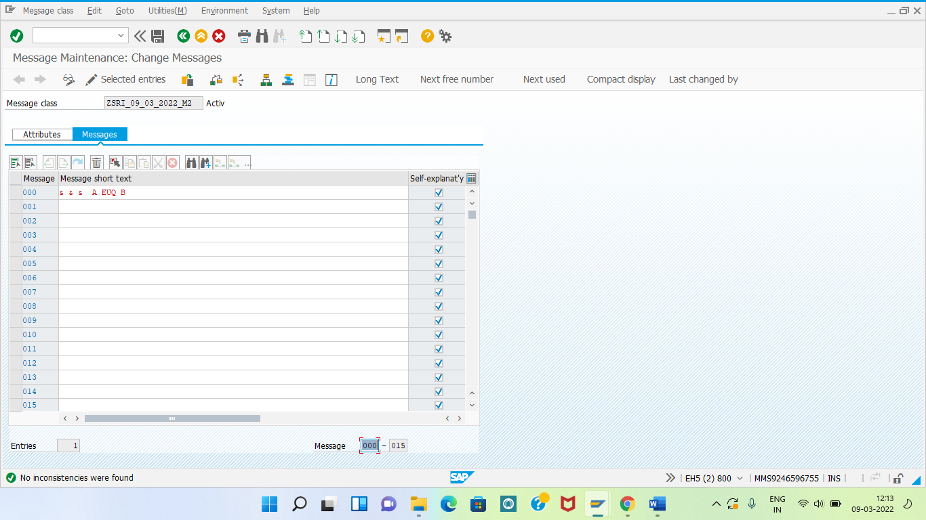
MESSAGE I000(ZSRI_09_03_2022_M2) WITH 'PRINCY' 'ANITHA' 'KANIMOZHI'.

12.What is the use of initial command?
Initial means no records in the internal table. Not initial means at least one record is there.
13.String manipulations?
CONCATENATE, CCONCATENATE RESPECTED BLANKS, SPLIT, TRANSLATE, STRING LENGTH, CONDENSE, CONDENSE NO-GAPS, REPLACE, FIND, REVERSE.
14.What are the types of structure?
Internal, External.
External structure
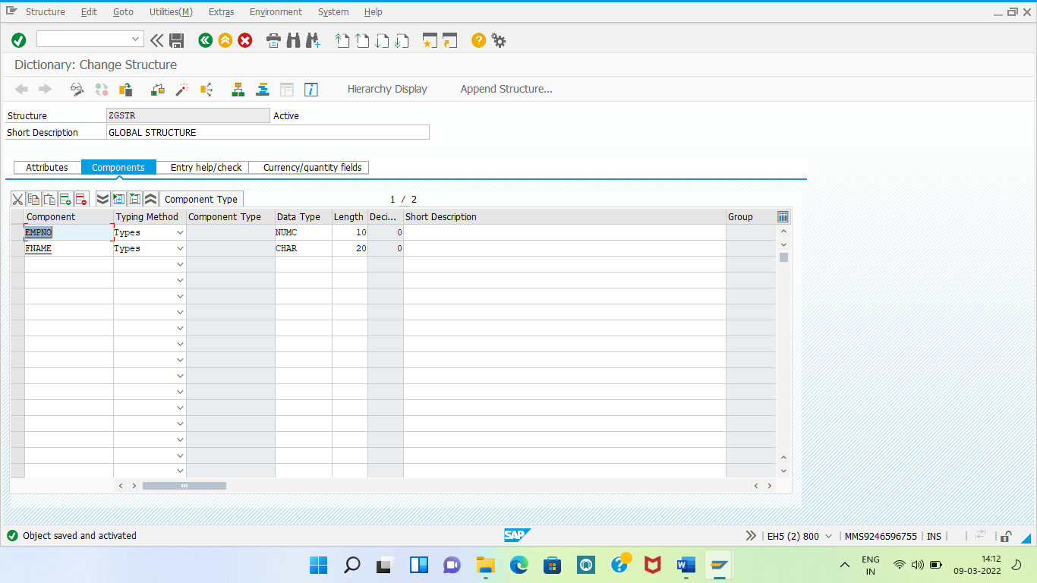
15.What is the difference between internal structure and external structure?
Internal structure local within program
REPORT Z09_03_OPERATORS_PR15.
DATA: BEGIN OF STR,
EMPNO(10) TYPE N,
FNAME(30) TYPE C,
END OF STR.
External structure Global we can use in any program.
REPORT Z09_03_OPERATORS_PR16.
DATA: BEGIN OF STR.
INCLUDE STRUCTURE ZGSTR.
DATA: END OF STR.

